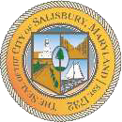

CITY OF SALISBURY
TRUTH COMMITTEE MEETING AGENDA
March 18, 2026 6:30 p.m.
Truitt Street Community Center

- Call to Order – Introductions and welcome

- Approval of February meeting minutes

- New Business

- Open Public Forum

- Announcements
- Schedule next meeting and adjourn

