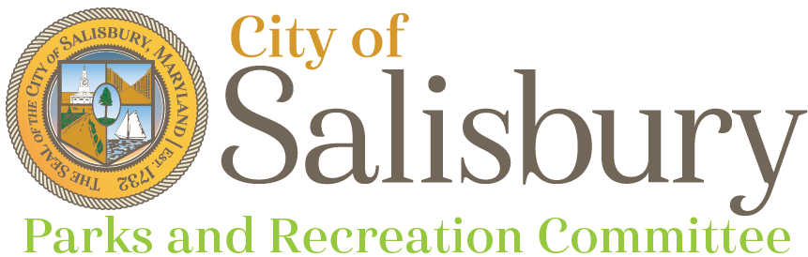
Meeting Agenda

Thursday, February 12, 2026
6:00 pm
Community Foundation of the Eastern Shore

- Welcome
- Staff updates (10 min)
  - Matt Obert - Field Ops
- City Park Construction Discussion
- Playgound Improvements Discussion
- Park’s CIP Requests
- Committee and public comments, questions (5 min)
- Adjournment
Next Meeting
- April 9, 2026 – Jeanette P. Chipman Boundless Playground

