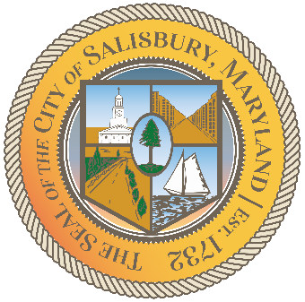

**CITY OF SALISBURY**

**HUMAN RIGHTS ADVISORY COMMITTEE MEETING AGENDA**

Picture 8

|  |  |
| --- | --- |
| **August 6, 2025** | **6:00 p.m.** |
|  | **HQ Conference Room** |

Picture 9

1. **Call to Order – Introductions and welcome**
2. **Approval of July minutes**

1. **Requested Agenda Items**
   1. **Discuss future goals of the committee amidst transition**
   2. **Outline community goals and vision**
2. **Open public forum and current events**
3. **Announcements**
4. **Schedule next meeting and adjourn**