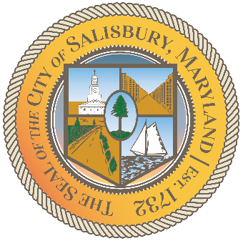

**CITY OF SALISBURY**

**TRUTH COMMITTEE MEETING AGENDA**

Picture 8

|  |  |
| --- | --- |
| **July 16,2025** | **6:00 p.m.** |
|  | **HQ Conference Room** |

Picture 9

1. **Call to Order – Introductions and welcome**

1. **Open Public Forum**
2. **Announcements**
3. **Schedule next meeting and adjourn**