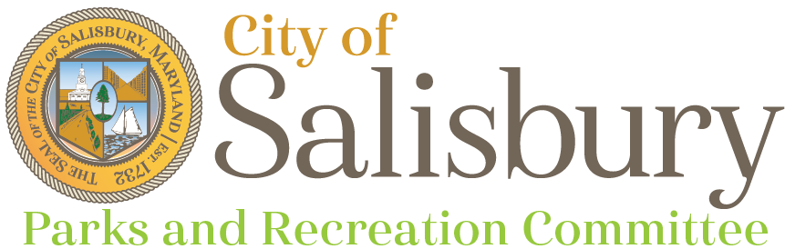

**Meeting Agenda**

Thursday, June 12, 2025

6:00 pm

Johnson Lake Neighborhood Playground

* Welcome
* Staff updates (10 min)
  1. Matt Obert - Parks Manager
* Approval of Minutes (10 min)
* Review of Proposed Parks Rules & Regulations
* Committee and public comments, questions (5 min)
* Adjournment

Next Meeting

* July 10, 2025 - Lake Street Park and Playground