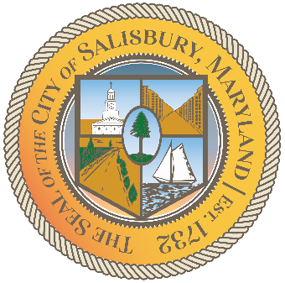

**CITY OF SALISBURY**

**TRUTH COMMITTEE MEETING AGENDA**

Picture 8

|  |  |
| --- | --- |
| **June 18, 2025** | **6:00 p.m.** |
|  | **HQ Conference Room** |

Picture 9

1. **Call to Order – Introductions and welcome**

1. **Current works for discussion**
2. **Future Events**

1. **Open public forum and current events**
2. **Announcements**
3. **Schedule next meeting and adjourn**