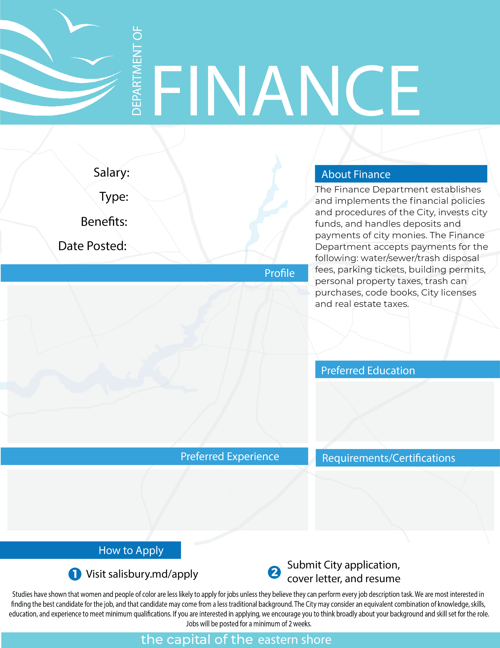

**ASSISTANT DIRECTOR FINANCE - OPERATIONS**

$86,670-$93,815

Full Time

Full Benefits

12/06/2024

Under the supervision of the Director of Finance, the Assistant Director of Finance - Operations is a key member of the Finance team. This position will be responsible for reconciling accounts receivable, grant accounting, and other general ledger accounts. The Assistant Director will be responsible for assisting with the budget and annual audit. The Assistant Director will provide support to the Director of Finance as needed to support the Finance office in delivering efficient and effective municipal services at a high level of customer satisfaction.

Excellent written and verbal communication skills. Experience with Microsoft Office with proficiency in Excel.

Bachelor’s Degree in Accounting, Finance, Business Administration, or a related field required.

A minimum of seven (7) years of progressively responsible professional accounting and administrative experience in local government finance, four (4) years of which must have been in a supervisory capacity.