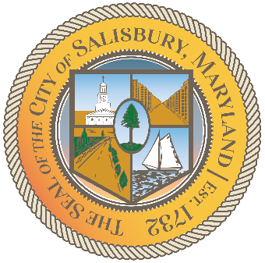

**CITY OF SALISBURY**

**TRUTH COMMITTEE MEETING AGENDA**

Picture 8

|  |  |
| --- | --- |
| **December 18, 2024** | **6:00 p.m.** |
|  | **HQ Conference Room** |

Picture 9

1. **Call to Order – Introductions and welcome**

1. **Current works for discussion** 
   1. **Black History Month preparation**
   2. **Vote on Vision Statement—update**
   3. **Know Your Rights seminar**
2. **Future Events**
   1. **Next outreach event for the public**
   2. **BH Walking Tours—February 2025**

1. **Open public forum and current events**
2. **Announcements**
3. **Schedule next meeting and adjourn**