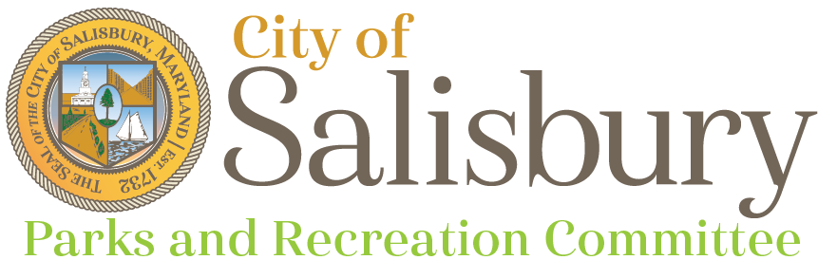

**Meeting Agenda**

Thursday November 14, 2024

6:00 pm

Headquarters Conference Room

* Welcome
* Staff updates (10 min)
  1. Matt Obert - Parks Manager
* Approval of Minutes (10 min)
* Parks Rules and Regulation Update and Review
* Committee and public comments, questions (5 min)
* Adjournment

Next Meeting

* December 12, 2024 - HQ Conference Room