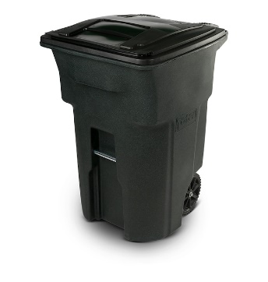
City of Salisbury
2024 Holiday Trash & Recycling Schedule
Trash and Recycling Will be collected on…
not collected on…
Friday, March 29  Good Friday | Saturday, March 30
Monday, May 27  Memorial Day | Tuesday, May 28
Wednesday, June 19  Juneteenth | Saturday, June 22
Thursday, July 4  4th of July | Saturday, July 6
Monday, September 2  Labor Day | Tuesday, September 3
Monday, November 11  Veteran’s Day | Tuesday, November 12
Thursday, November 28  Thanksgiving Day | Saturday, November 30
Wednesday, December 25  Christmas Day | Saturday, December 28
Wednesday, January 1  New Year’s Day | Saturday, January 4
*Holidays that land on trash/recycling pickup dates, but not listed above, are NOT AFFECTED and normal service will be provided on those dates. For holidays that fall on Monday, there will be no yard waste or bulk pickup that week.

