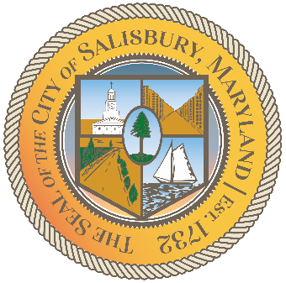

**CITY OF SALISBURY**

**DISABILITY ADVISORY COMMITTEE MEETING AGENDA**



**May 7, 2024 3:00 p.m.**

**Government Office Building 306**

**Zoom:** <https://us02web.zoom.us/j/89485773547?pwd=VFBDd3piSE5xL2ZrWDFqa0RrS1Z3QT09>



1. Call Meeting to Order
2. Welcome and Member Introductions
   1. Welcome New Member – Ms. Virginia Bender
3. Review March Minutes
4. Reminders
   1. Tabling at “Colors of Holi” Festival
      1. Saturday, May 11th from 1PM to 5PM at Winterplace Park
   2. Support Dominique Sessa in Competing for Ms. Wheelchair US
      1. She has a fundraising page to collect donations. Please spread the word to your networks. Adith will send link privately following meeting.
5. Call to Ursula Myers – Citizen with Concerns About Shore Transit – Katherine
6. Active DAC Projects
   1. Citizen Problem Reporter Report – Adith
      1. In progress with GIS team at City
   2. Wheelchair Charging Stations Update – Adith
      1. Project on hold as DID Responsibilities are reshuffled
   3. Accessible Public Transportation – Adith
      1. City has hired RK&K to perform an audit of all public transportation options available and propose/implement solutions.
      2. Currently in information gathering phase. Would like input on survey from stakeholders.
      3. Survey link: <https://arcg.is/1C1XXa0>
7. DAC Logo and Branding – Adith
8. DAC Bylaws - Adith
9. Agency Updates
10. Open Discussion/Concerns for DAC to address
11. Set Next Meeting (7/11/2024 at 3:00 pm)
12. Adjourn