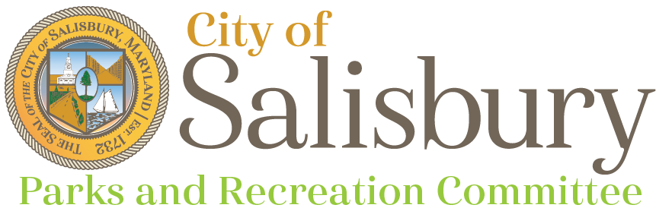
Meeting Agenda

Thursday, March 14, 2024
6:00 p.m.

Community Foundation of the Eastern Shore

- Welcome
- Staff updates
- Introductions and welcome to new members
- Review of Minutes
- Review of old business/ pending projects
- NRPA Health Equity Framework
- Park Visit Schedule and Goals
- Questions, Comments, & Concerns
- Adjournment
Next Meeting
- April 11, 2024 - Location TBD

