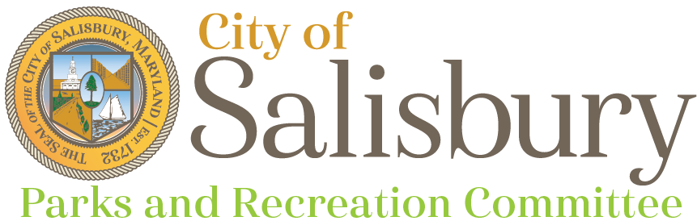
Meeting Agenda

Thursday, February 8, 2024
6:00 p.m.

Community Foundation of the Eastern Shore

- Welcome/ Introductions
- Approval of Minutes
- Parks Staff Updates
- Disc Golf Updates
  - Signage Update for Chris Roberts Memorial course
  - Papa Bear’s Run design plan discussion
  - Discussion about impact, conservation, stewardship and environmental priorities
- Opportunities for Committee Collaboration (Parks, Green Team, BPAC)
- Questions, Comments, & Concerns
- Adjournment
Next Meeting
- March 14, 2024 – Community Foundation of the Eastern Shore 6pm

