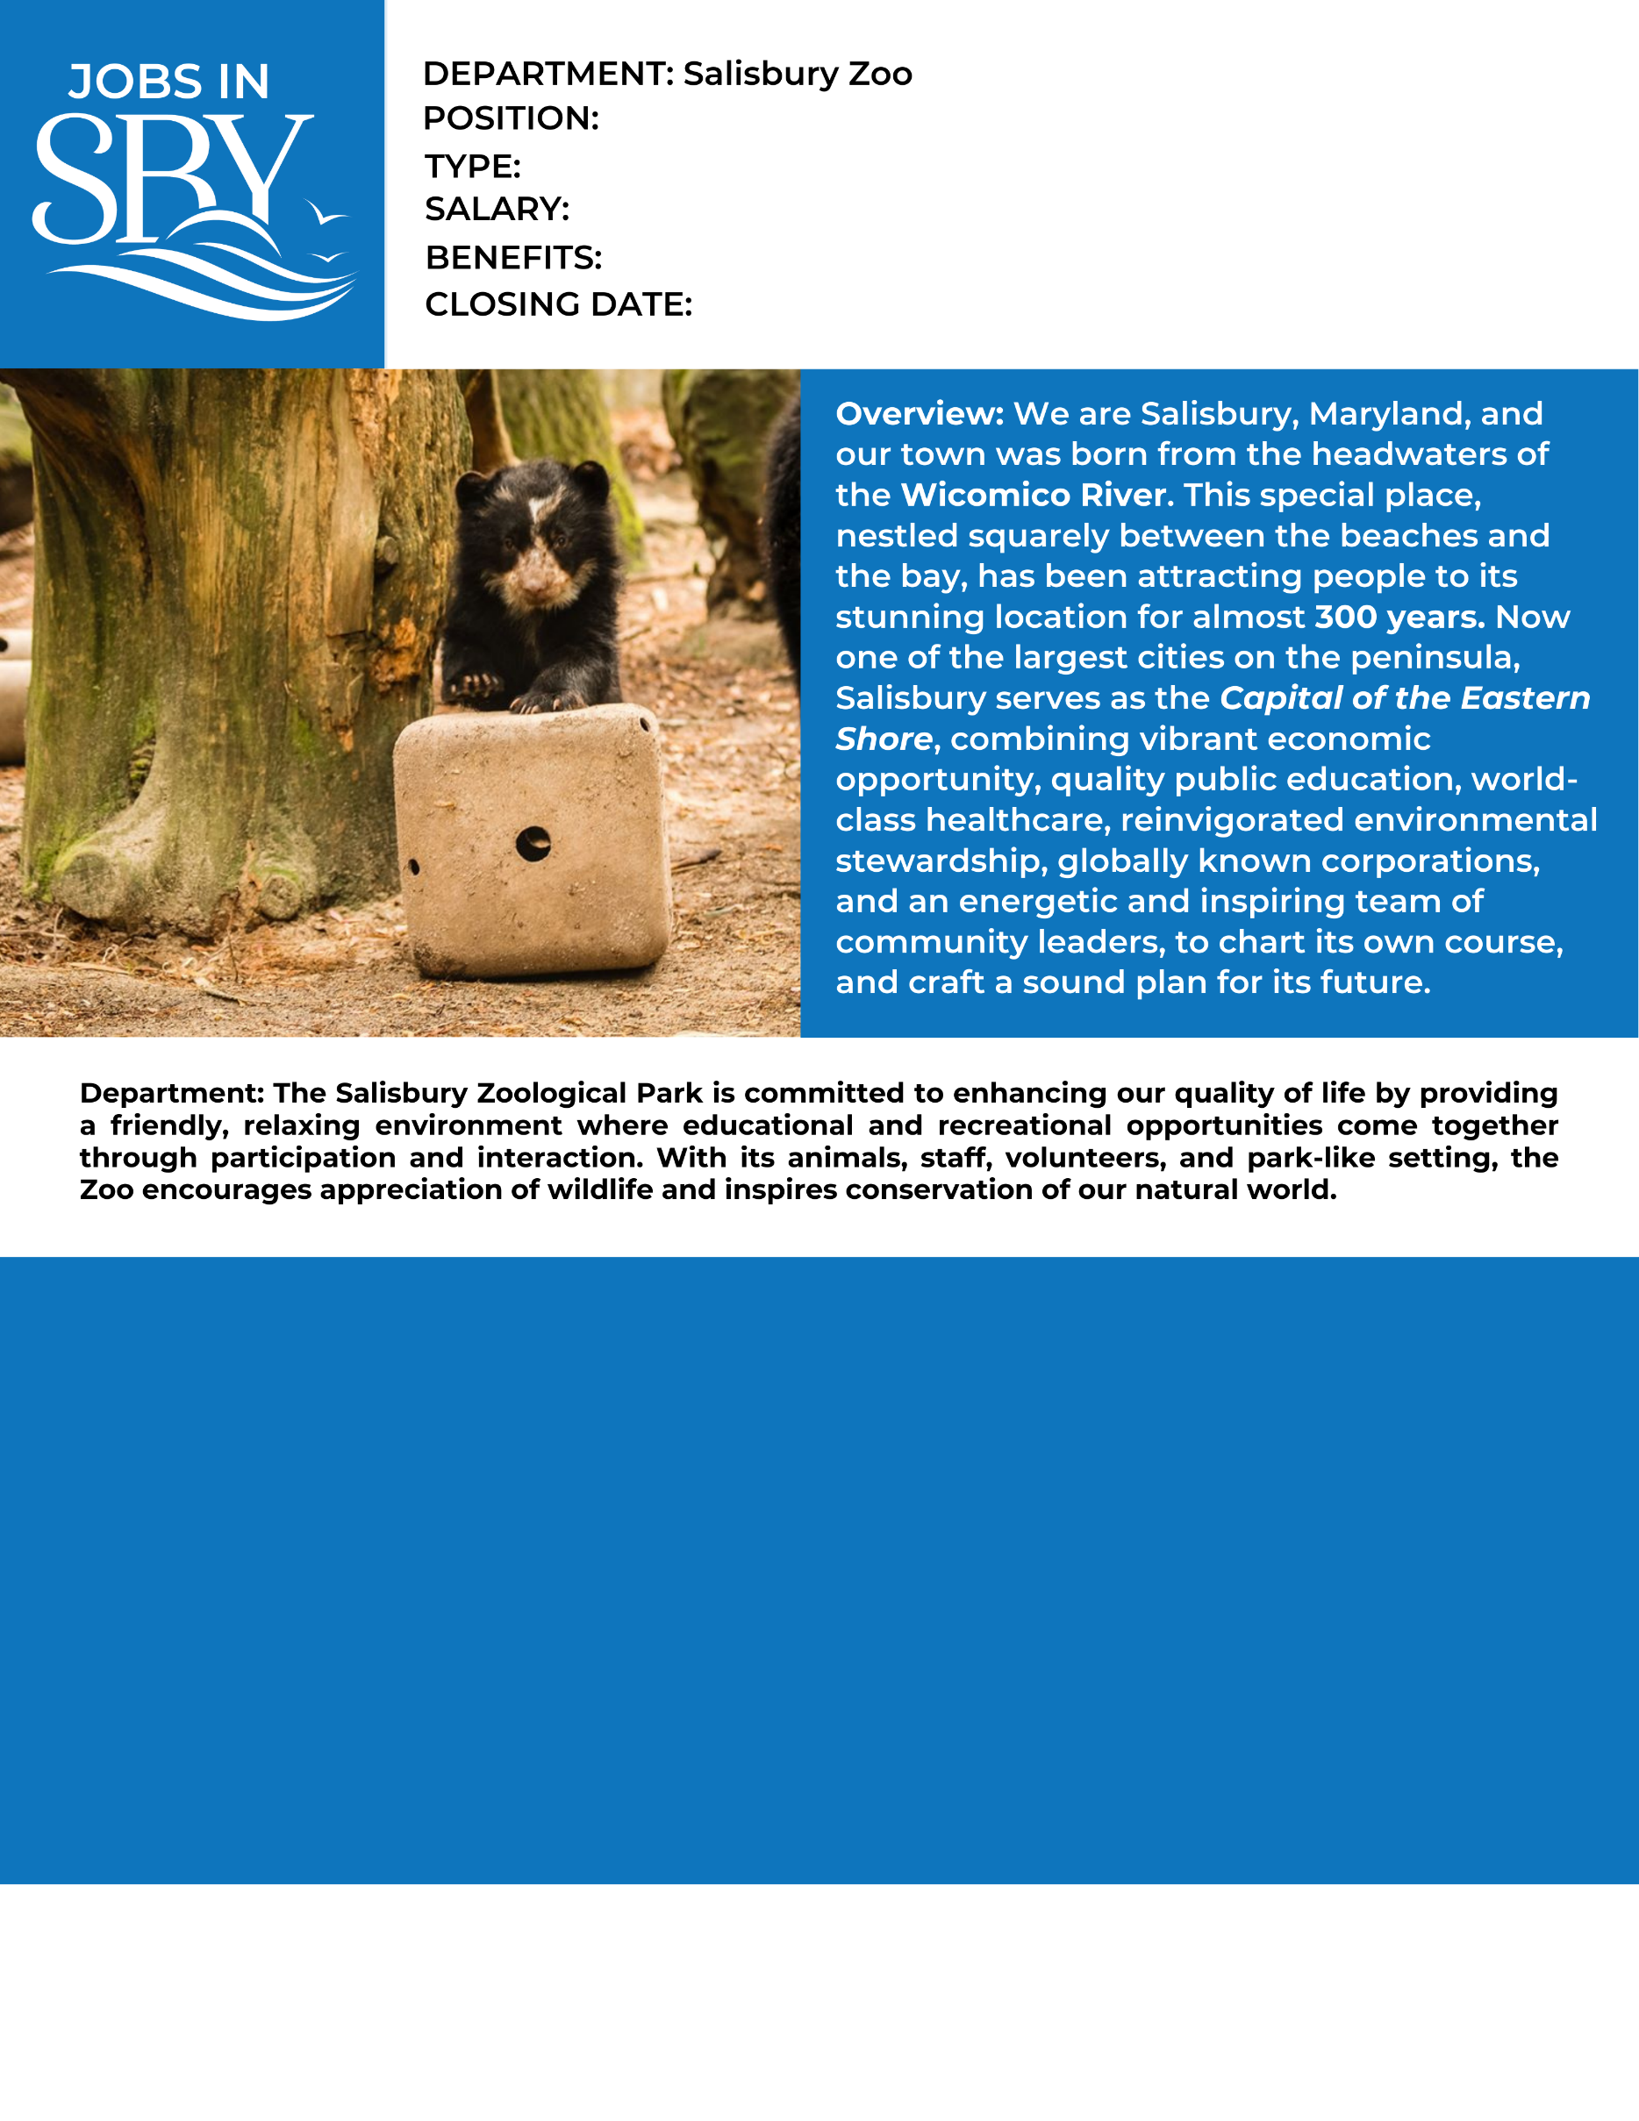

Under the direct supervision of the Education Curator and the Education Technician, the part-time Zoo Educator will educate children about animals and conservation. Primary duties include implementing zoo education programs on and off site, assisting with zoo events, representing the zoo at community events, and assisting in Ambassador Animal care and husbandry. Additional duties will include the preparation of Zoo birthday parties (Wild Party) and Zoo overnights (ZooSnooze).

High School Diploma; Preference will be given to candidates seeking a career in education, biology, or a related field.

Experience teaching/working with children, exotic animal handling is a plus.

Valid driver’s license, weekends required, occasional evenings required for special events. Must be willing to participate in special events on and off the zoo grounds.

N/A

Part Time

Educator

**How to Apply:** Submit City application, cover letter, driving record and resume to the following address or apply online at [www.salisbury.md/apply](http://www.salisbury.md/apply)

Studies have shown that women and people of color are less likely to apply for jobs unless they believe they can perform every job description task. We are most interested in finding the best candidate for the job, and that candidate may come from a less traditional background. The City may consider an equivalent combination of knowledge, skills, education, and experience to meet minimum qualifications. If you are interested in applying, we encourage you to think broadly about your background and skill set for the role.

Requirements/Certifications:

Preferred Experience:

Preferred Education:

Profile:

13.25/hr

Continuous