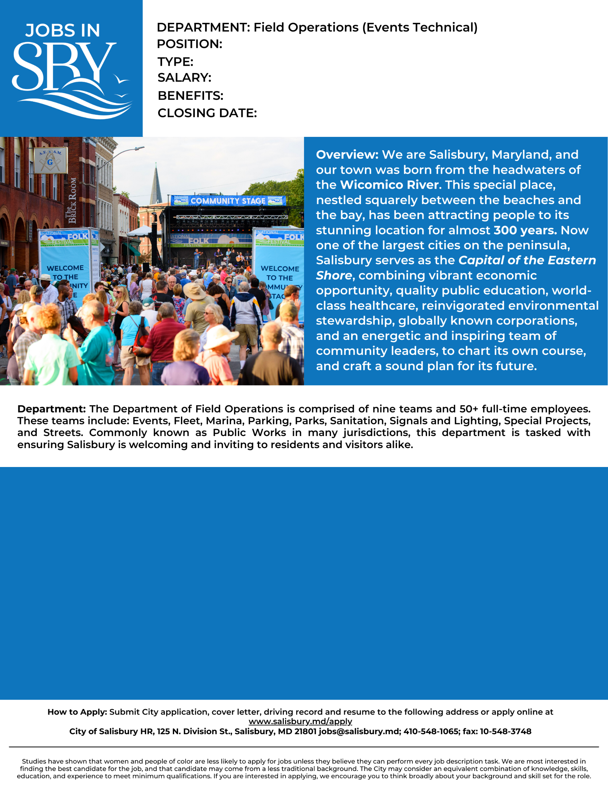

This position provides operational support to the Department of Field Operations by performing manual, semi-skilled and skilled work and operating heavy trucks and equipment. Duties include general landscaping work such as mowing, trimming, weeding, mulching and planting. Maintaining roadside ditches, drainage areas, shoulders and park grounds by removing weeds and applying herbicides. Although allocated to Parks, this position requires cross-training in other divisions (Streets, Traffic and Sanitation) to support the activities of the Department

Full

Trainee $31,543, Tech I $32,745, Tech II $34,749 DOQ

Field Ops Tech-Parks

Open until filled.

Non-Exempt

Requirements:

Trainee: No related experience required.

Level I: Six months of related experience.

Level II: Three years of related experience.

Preferred Experience:

High School Diploma or GED required

Preferred Education:

Trainee: Valid Driver’s License

Level I: All Trainee requirements, CDL Learner’s Permit and DOT Medical Card, Flagger Certification.

Level II: All Level 1 requirements, CDL Class B with airbrake endorsement

Profile: