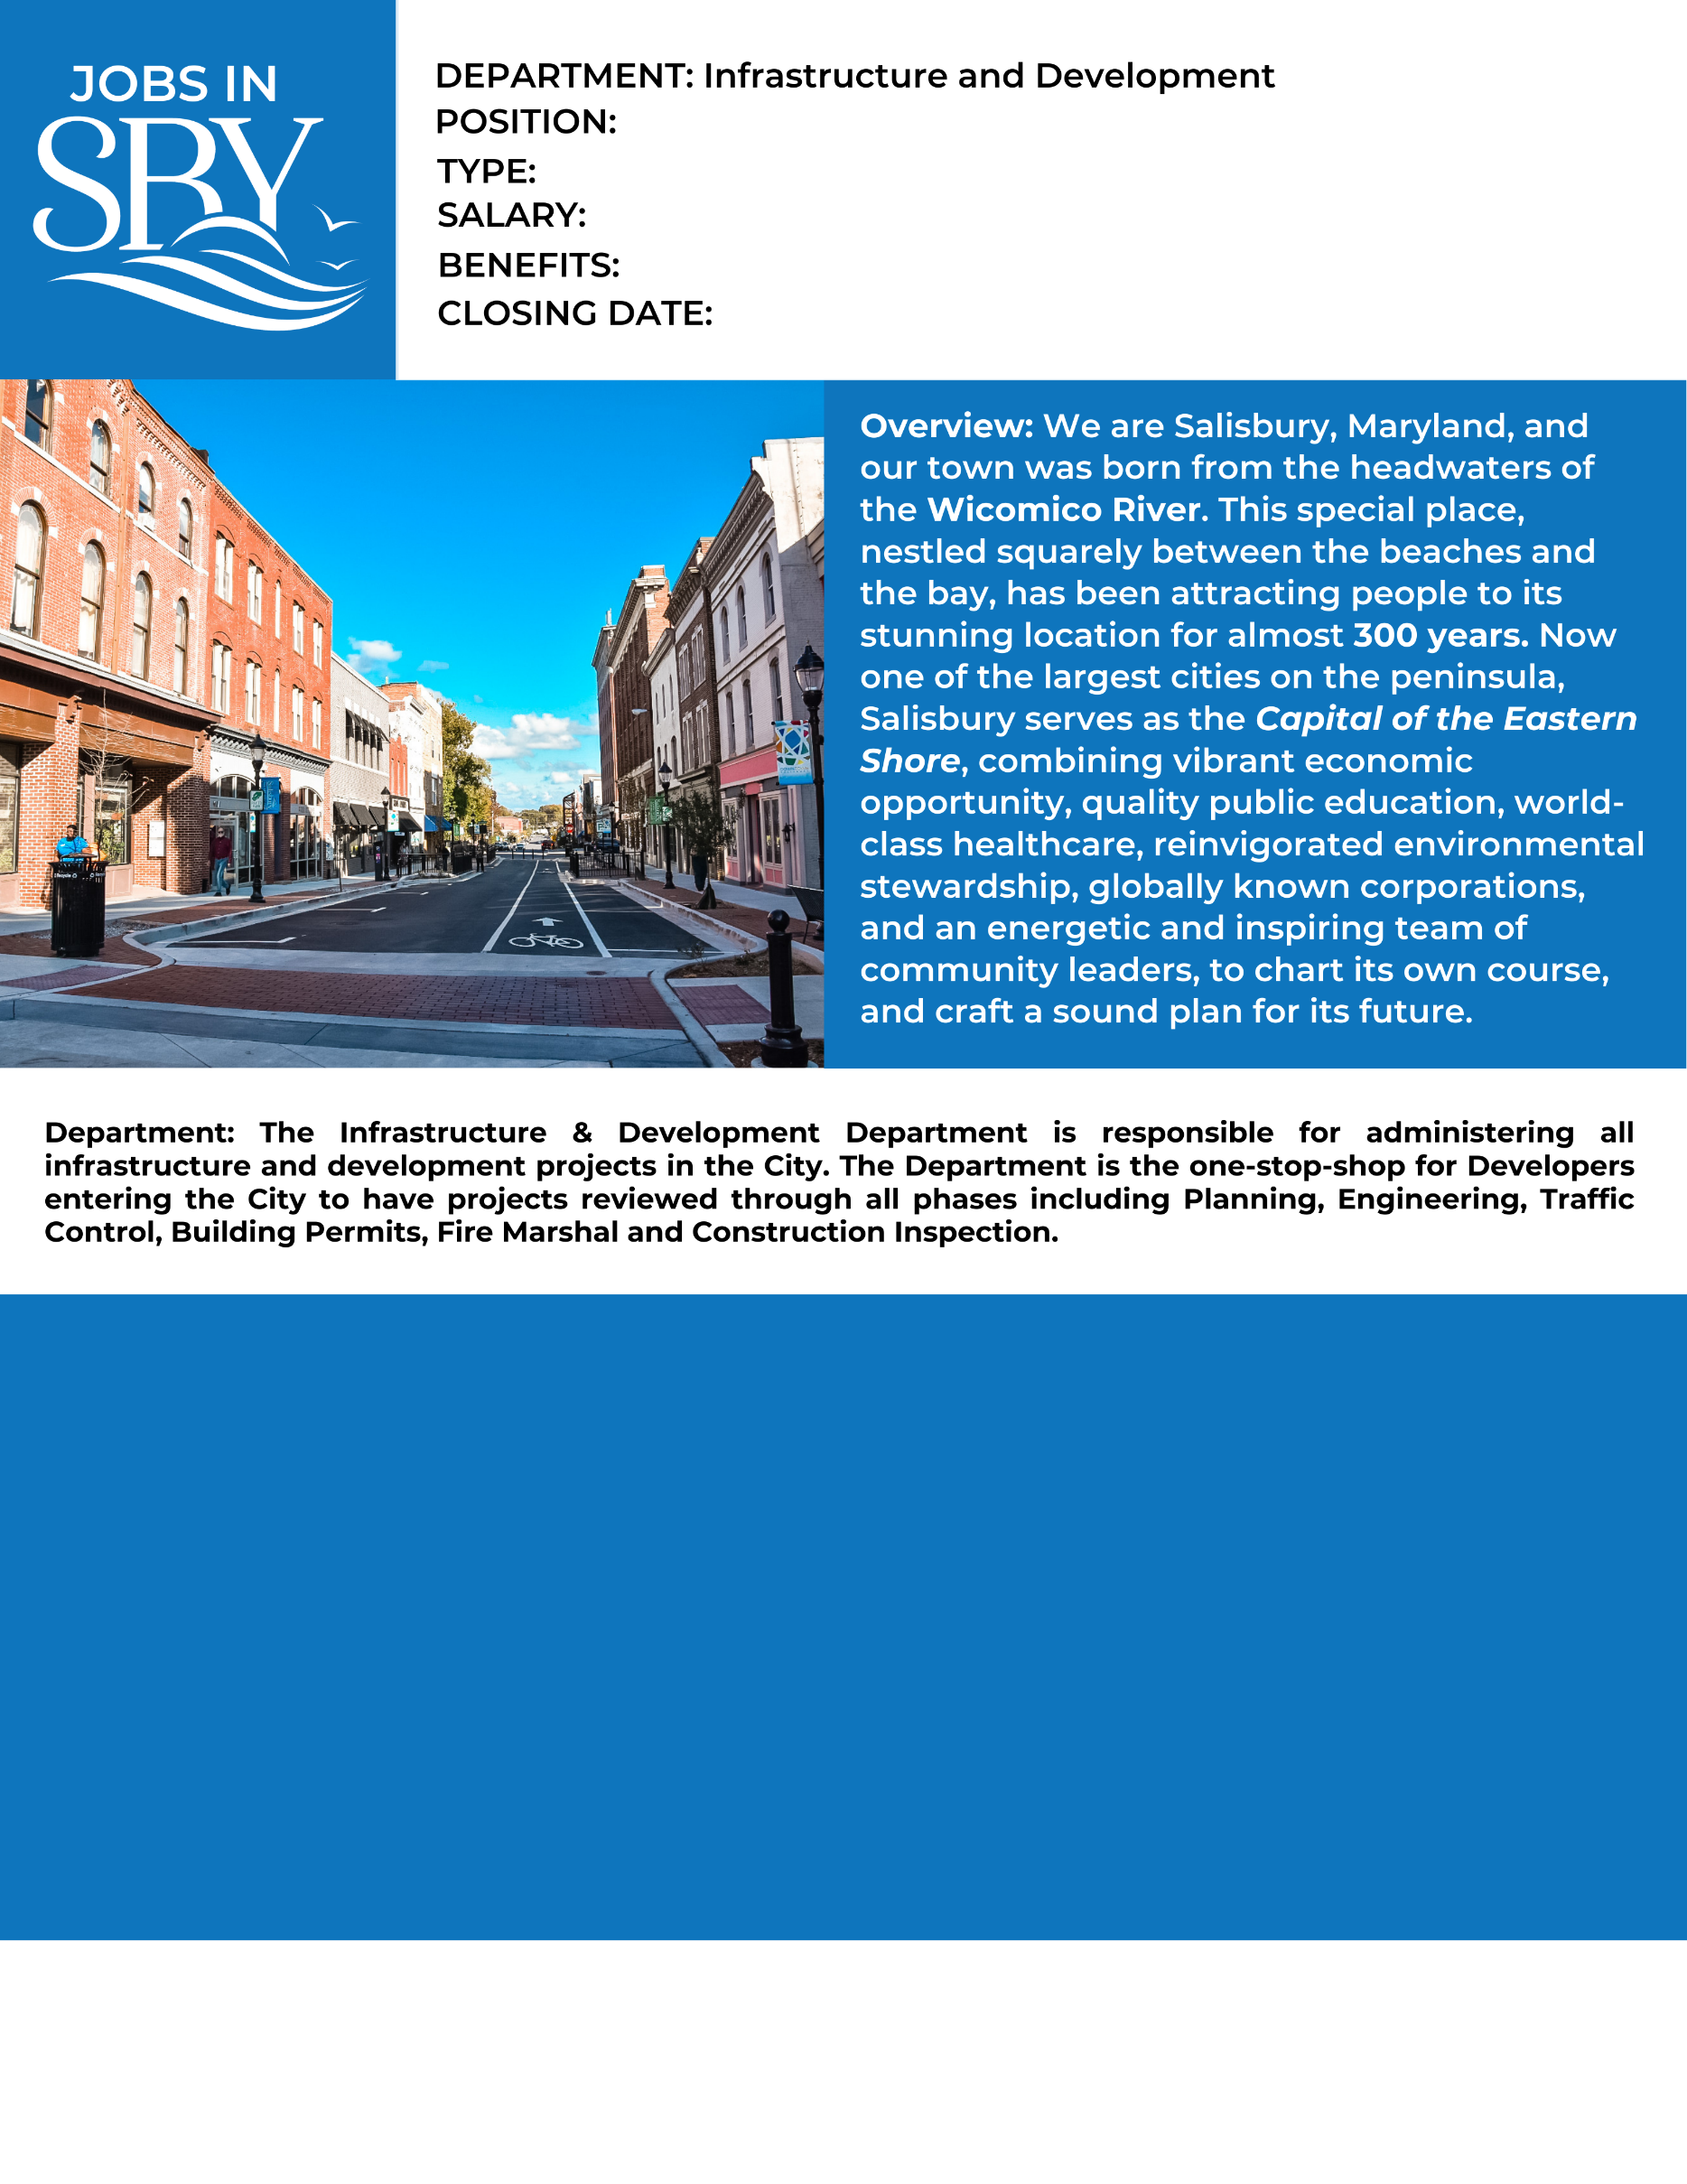

Preferred Education: (4) year ABET accredited Engineering Program

Profile: Transportation Engineer develops and reviews plans for municipal streets, associated surface transportation and appurtenances according to NACTO Standards, AASHTO standards and tenets of Vision Zero; develops transportation strategies, preforms analysis; prepares in-house designs, specifications, standards and cost estimates, reviews plans involving transportation facilities; preforms other duties as assigned.

Preferred Experience: City of Salisbury is interested in interviewing interested candidates and will make decisions in part based on experience. entry level, supervisory level and senior level engineers looking for creative individuals who can readily adapt to a variety of challenges

Requirements/Certifications: Valid State of Maryland Driver’s License required, preference given to EIT or PE, MUTCD Certification and IMSA Certification.

**How to Apply:**

Submit City application, cover letter, driving record and resume online at [www.salisbury.md/apply](http://www.salisbury.md/apply)

Studies have shown that women and people of color are less likely to apply for jobs unless they believe they can perform every job description task. We are most interested in finding the best candidate for the job, and that candidate may come from a less traditional background. The City may consider an equivalent combination of knowledge, skills, education, and experience to meet minimum qualifications. If you are interested in applying, we encourage you to think broadly about your background and skill set for the role.

Full Benefits

Full-time (35hrs/week)

Open Until Filled

Based on Level and Experience

Engineering – Transporation