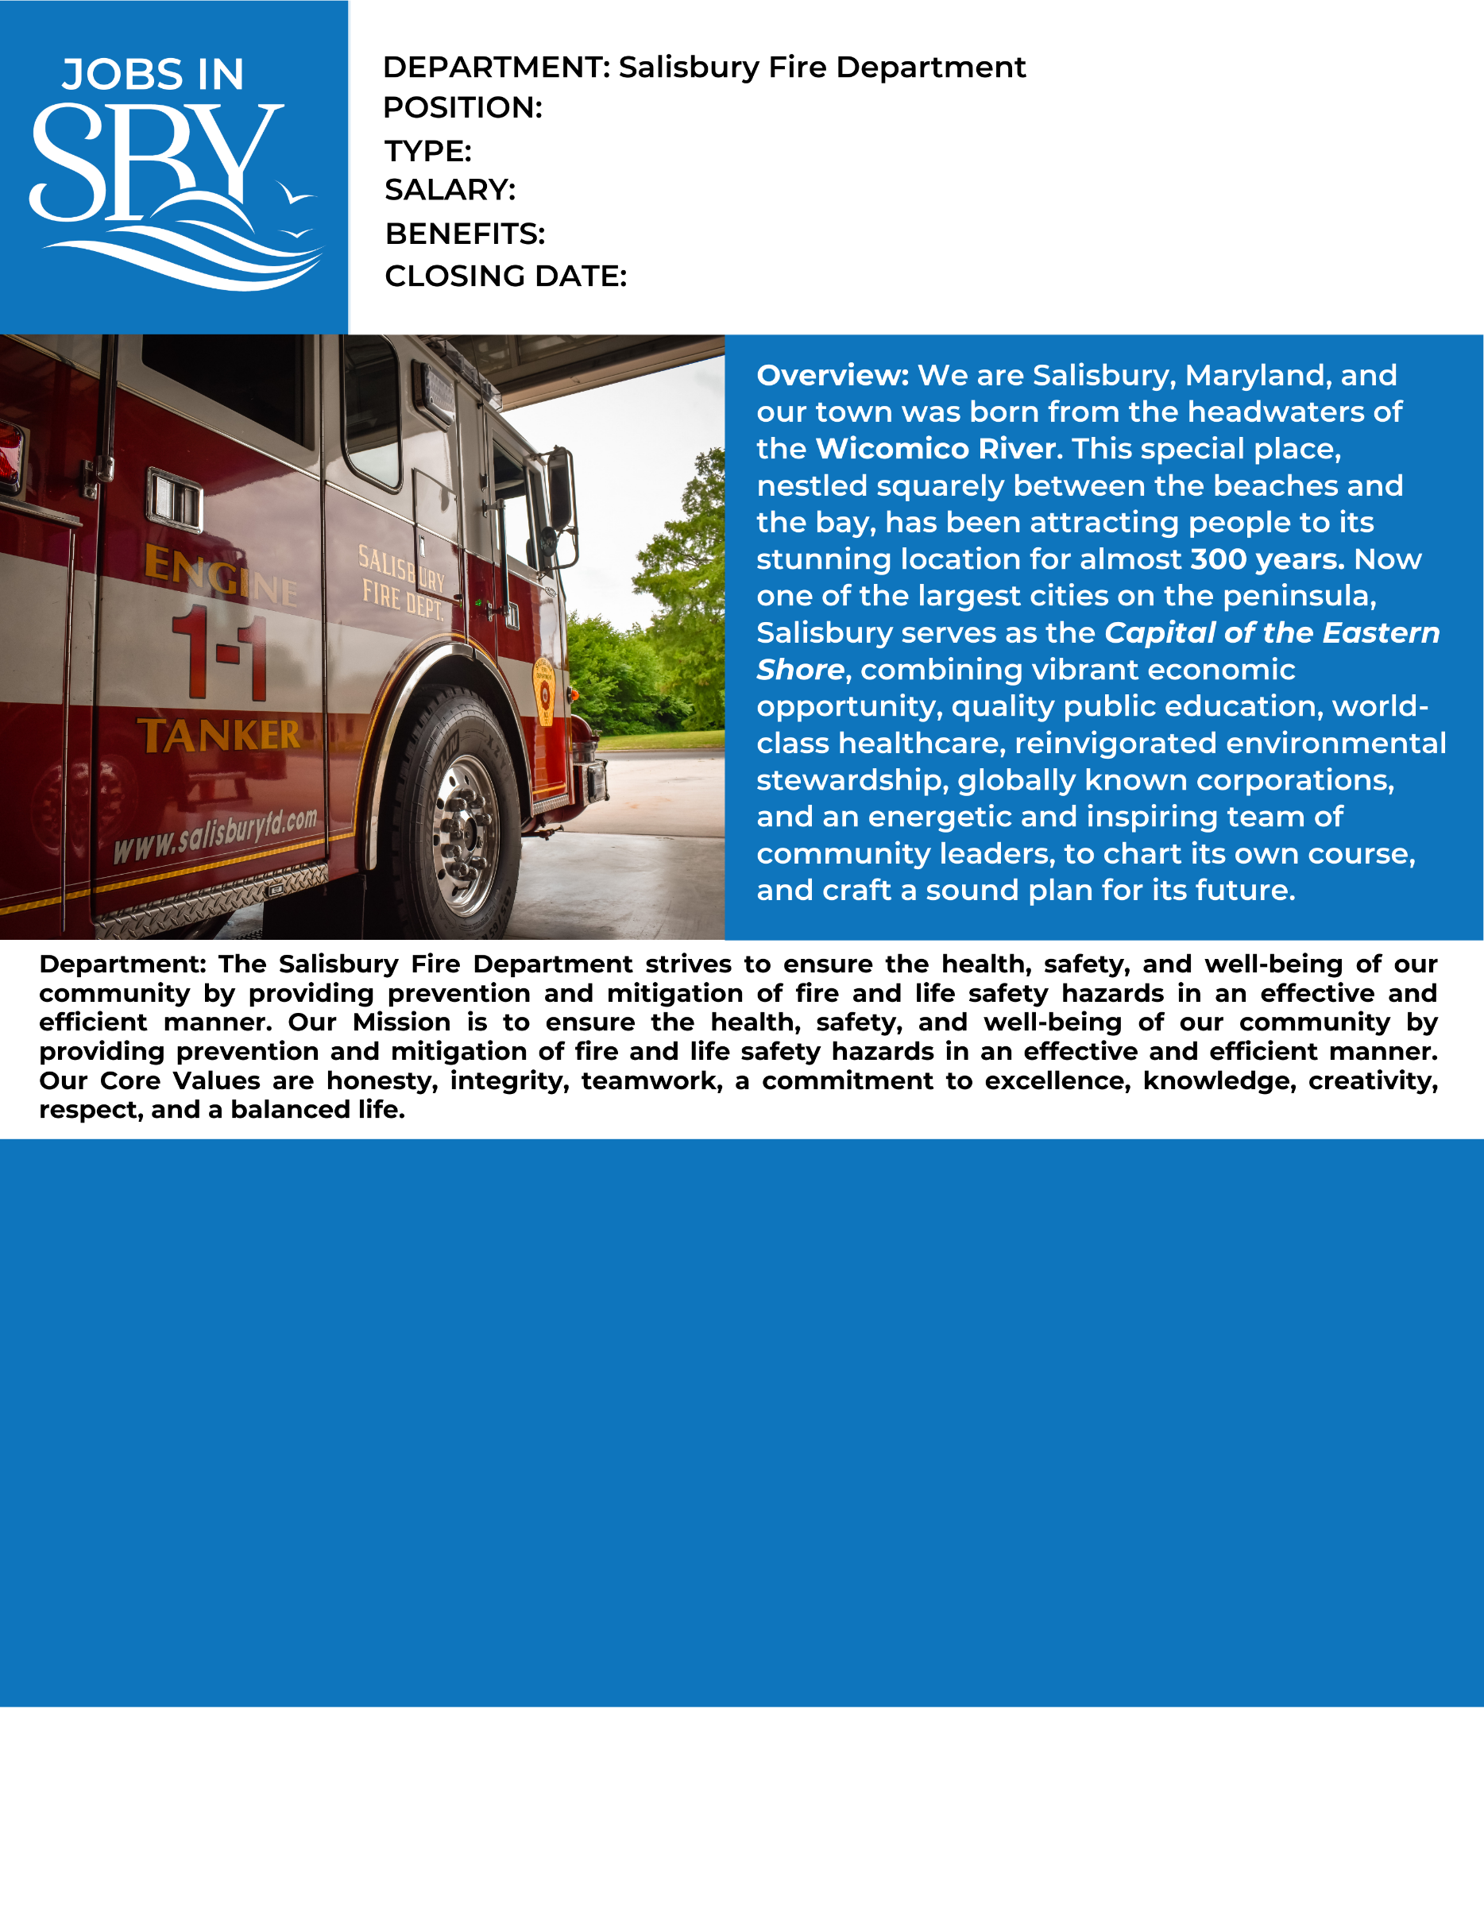

September 30, 2022 at 4:00 pm

Full Range of Benefits

$43,758 (Selected candidate will receive a $10,000 Sign-on bonus)

Full-time/Part-time

Firefighter/Paramedic

Prior to employment you must have the following: Current licensure as a Paramedic; Class “C” MD driver’s license or equivalent; Firefighter I and hazardous materials (operations).

**Profile:**

Candidates must be trained and proficient in fire suppression, rescue and emergency medical services at the advanced life support (ALS) level. Persons applying for these positions must be at least 18 years of age on the date of appointment and must pass a written and a physical agility test. Candidates selected for appointment will be required to undergo a comprehensive physical examination as well as a background investigation. Candidates not selected will be placed on an active hiring list for future consideration.

Testing will take place Saturday, October 15, 2022 starting promptly at 8:00 am at the Salisbury Fire Department Administrative Headquarters located at 325 Cypress Street in Salisbury MD. (Please bring all your turnout gear on day of testing). All applicants must review the information listed in the Fire Department’s Application Packet. The Fire Department’s Application Packet can be picked up Monday thru Friday from 8:30 am until 4:30 pm at the Salisbury Fire Department Administrative Headquarters or found on-line at www.salisbury.md/careers.

High School Diploma or G.E.D

**Requirements/Certifications:**

**Preferred Education:**

**How to Apply:** Submit City application, cover letter, driving record and resume online at [www.salisbury.md/apply](http://www.salisbury.md/apply)

**City of Salisbury HR, 125 N. Division St., Salisbury, MD 21801 jobs@salisbury.md; 410-548-1065; fax: 10-548-3748**