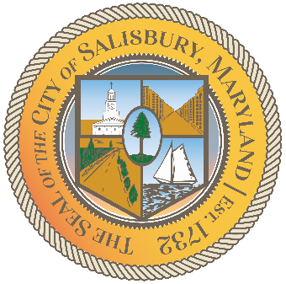

**CITY OF SALISBURY**

**ETHICS COMMISSION MEETING AGENDA**



**September 13, 2022 3:30 pm**

**Government Office Building 306**



1. Call Meeting to Order
2. Review of July 8, 2022 meeting minutes
3. Review of Salisbury Amended Ethics Ordinance
4. Open Discussion
5. Set next meeting if necessary
6. Adjourn