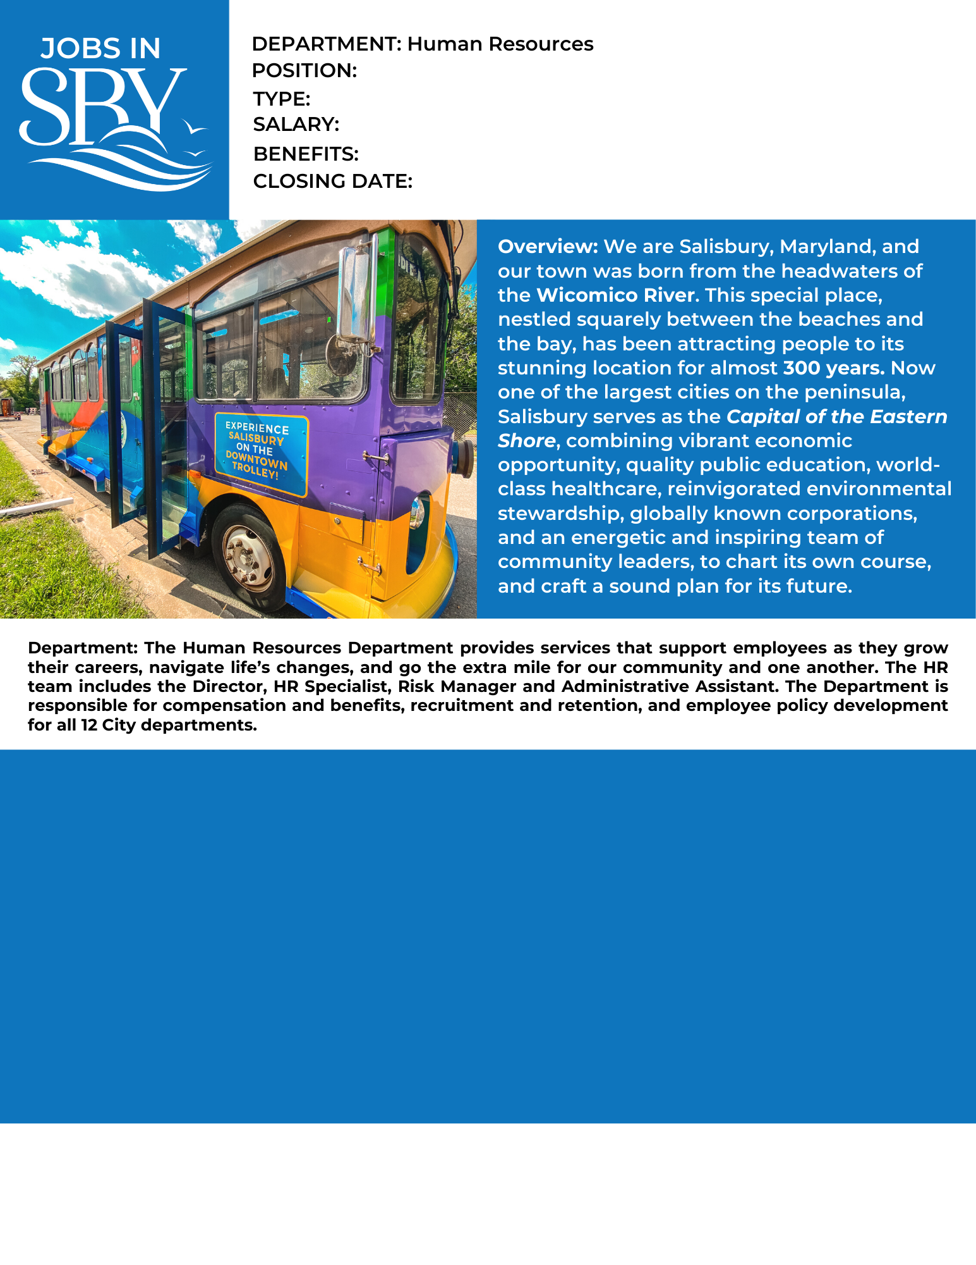

The Human Resources Specialist performs professional human resources work in the development and administration of programs such as benefits, retirement, compensation, Family Medical Lave, processing documentation and other duties as assigned. Work involves interpreting, explaining and applying laws and offering guidance and direction to employees and leadership.

Preferred Education:

Preferred Experience:

At least two years of benefits experience required. Excellent written and verbal communication skills and interpersonal skills are essential.

Bachelor’s degree in human resources, communications or a related field.

Full-time (35 hrs/week)

Full Benefits

Open until filled

$48,110 - $52,076 (range depending on experience)

**How to Apply:** Submit City application, cover letter, driving record and resume to the following address or apply online at [www.salisbury.md/apply](http://www.salisbury.md/apply)

Studies have shown that women and people of color are less likely to apply for jobs unless they believe they can perform every job description task. We are most interested in finding the best candidate for the job, and that candidate may come from a less traditional background. The City may consider an equivalent combination of knowledge, skills, education, and experience to meet minimum qualifications. If you are interested in applying, we encourage you to think broadly about your background and skill set for the role.

Human Resources Specialist (Benefits)

Profile: