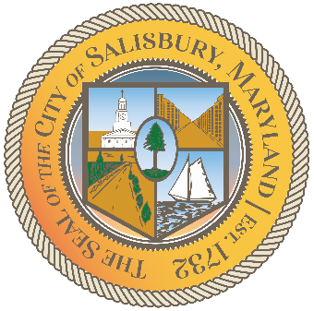

CITY OF SALISBURY

HUMAN RIGHTS ADVISORY COMMITTEE MEETING AGENDA

April 14, 2022 | 6:00 p.m.
Government Office Building | Virtual Meeting

MEETING LINK— https://us02web.zoom.us/j/82398047738

Item I Call to Order – Introductions and welcome

Item II Approval of March Meeting Minutes

Item III Current works for discussion

Item IV Open public forum and current events

Item V Announcements

Item VI Schedule next meeting and adjourn

