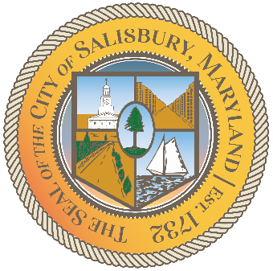

**CITY OF SALISBURY**

**DISABILITY ADVISORY COMMITTEE MEETING AGENDA**



**March 10, 2022 3:00 p.m.**

**Government Office Building 306 Hybrid**



1. Call Meeting to Order
2. Welcome and Introductions
3. December Minutes Review
4. Elect 2022 Chairperson
5. DAC Applicant Introductions
6. Progress Reports
   1. Video Update
   2. Social Media Page Update
   3. Ramp at Visitor Center
7. Agency & Vulnerable Population Updates
8. Open Discussion
9. Announcements
10. Set next meeting according to approved 2022 calendar