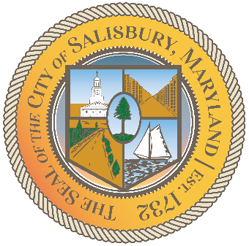

CITY OF SALISBURY

HUMAN RIGHTS ADVISORY COMMITTEE MEETING AGENDA

February 10, 2022 | 6:00 p.m.
Government Office Building | Virtual Meeting

MEETING LINK—
https://us02web.zoom.us/j/88359300673

Item I Call to Order – Introductions and welcome

Item II Approval of November Meeting Minutes

Item III Current works for discussion
- Vote on final draft of the HRAC Social Media Plan
- Human Rights Awards Updates
- City of Salisbury Housing First Program

Item IV Open public forum and current events
- February – Black History Month

Item V Announcements

Item VI Schedule next meeting and adjourn

