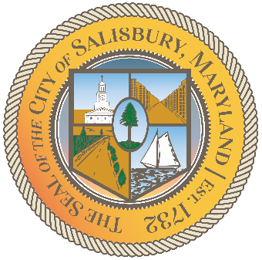

**CITY OF SALISBURY**

**DISABILITY ADVISORY COMMITTEE MEETING AGENDA**



**September 9, 2021 3:00 p.m.**

**Government Office Building 306 Hybrid**



1. Call Meeting to Order
2. Welcome and Introductions
3. June Minutes Review
4. Progress Reports
   1. Video Update
   2. Social Media Page Update
   3. Ramp at Visitor Center
5. Agency Updates
6. Vulnerable Populations Update
7. Announcements
8. Set next meeting for Thursday, December 9, 2021 and adjourn