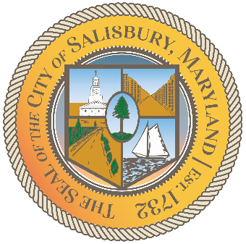

**CITY OF SALISBURY**

**DISABILITY ADVISORY COMMITTEE MEETING AGENDA**



**December 9, 2021 3:00 p.m.**

**Government Office Building 306 Hybrid**



1. Call Meeting to Order
2. Welcome and Introductions
3. September Minutes Review
4. Review & Approve 2022 Meeting Calendar
5. Elect 2022 Chairperson
6. Review DAC Applications (Ivy McIntyre & Ron Pagano)
7. Progress Reports
   1. Video Update—Chris Demone
   2. Social Media Page Update
   3. Ramp at Visitor Center
8. Agency Updates
9. Vulnerable Populations Update
10. Announcements
11. Set next meeting according to approved 2022 calendar