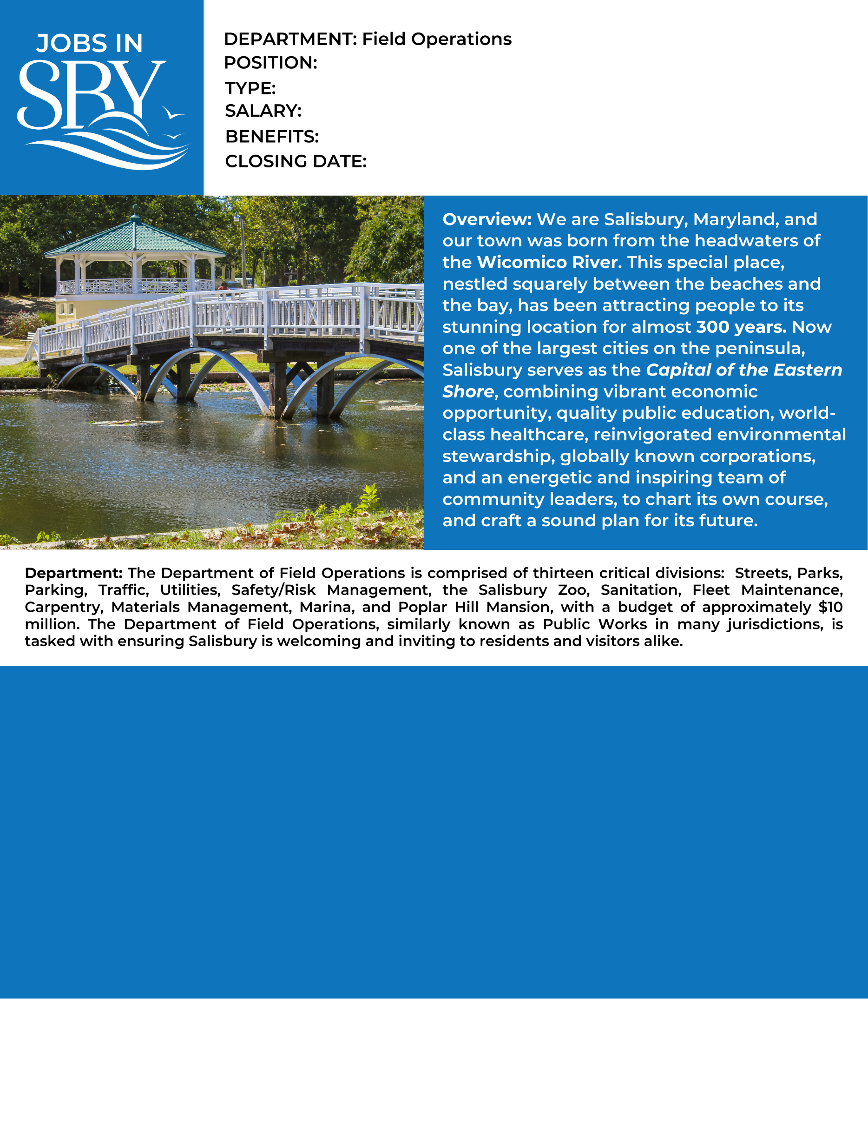

Vehicle Maintenance Supervisor Supervisor

Valid Driver’s License

Forklift certification

ASE G1, A-A9, L1-L3 and T1-T8 or equivalent.

Requirements/Certifications:

Preferred Experience: 5 years of experience with vehicular or equipment repair and maintenance or equivalent.

1-3 years supervisory experience

High School diploma or GED required.

Profile:

This position is responsible for scheduling and prioritizing day-to-day operations of the Fleet Management Division, supervising staff*,* monitoring budget expenditures, promoting and enforcing safe work practices, and providing back up coverage for all job classifications within the division. The responsibilities for this division include, but are not limited servicing and repairing City vehicles and equipment.

Required Education:

$49,185 DOQ

Full Benefits

**How to Apply:** Submit City application, cover letter, driving record and resume to the following address or apply online at [www.salisbury.md/apply](http://www.salisbury.md/apply)

**City of Salisbury HR, 125 N. Division St., Salisbury, MD 21801 jobs@salisbury.md; 410-548-1065; fax: 410-548-3748**

Open Until Filled

Full Time