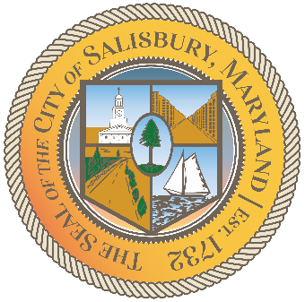

CITY OF SALISBURY

HUMAN RIGHTS ADVISORY COMMITTEE MEETING AGENDA

November 11th, 2021 | 6:00 p.m.
Government Office Building | Virtual Meeting

MEETING LINK— TBD

Opening meeting with a moment of silence

Item I Call to Order – Introductions and welcome 06:05 – 06:10

Item II Approval of October Meeting Minutes 06:10 – 06:15

Item III Current works for discussion 06:15 – 06:45
- Results of HRAC Officer elections
- Open to All Campaign - proposal

Item IV Open public forum and current events 06:45 – until
- Zakera Banks – Former Intern at Salisbury Mayor’s Office
  - Presentation on Redlining

Item V Announcements

Item VI Schedule next meeting and adjourn

