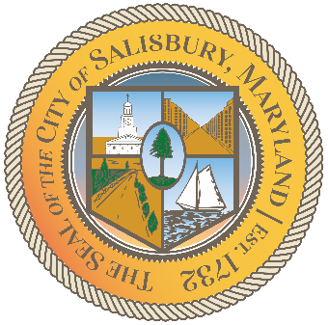

CITY OF SALISBURY

HUMAN RIGHTS ADVISORY COMMITTEE MEETING AGENDA

October 14th, 2021 | 6:00 p.m.
Government Office Building | Virtual Meeting

MEETING LINK— TBD

Opening meeting with a moment of silence

Item I Call to Order – Introductions and welcome 06:05 – 06:10

Item II Approval of September Meeting Minutes 06:10 – 06:15

Item III Current works for discussion 06:15 – 06:45
- Vote on Sally Perret’s application
- Open to All Campaign - updates
- Social Media Content
- Elect 2022 Chair, Co-Chair, Administrator
- Human Rights Award follow up w/Jessica
- HRAC Brochure follow up w/Jessica

Item IV Open public forum and current events 06:45 – until

Item V Announcements

Item VI Schedule next meeting and adjourn

