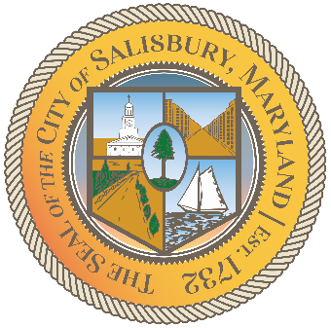

CITY OF SALISBURY

HUMAN RIGHTS ADVISORY COMMITTEE MEETING AGENDA

September 9th, 2021 | 6:00 p.m.
Government Office Building | Virtual Meeting

MEETING LINK— TBD

Opening meeting with a moment of silence

Item I Call to Order – Introductions and welcome 06:05 – 06:10
- Guest: Sally Perret

Item II Approval of August Meeting Minutes 06:10 – 06:15

Item III Current works for discussion 06:15 – 06:45
- Open to All Campaign - proposal
- Social Media Content

Item IV Open public forum and current events 06:45 – until

Item V Announcements

Item VI Schedule next meeting and adjourn

