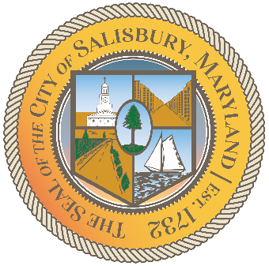

CITY OF SALISBURY

HUMAN RIGHTS ADVISORY COMMITTEE MEETING AGENDA

August 12th, 2021 | 6:00 p.m.
Government Office Building | Virtual Meeting

MEETING LINK— TBD

Opening meeting with a moment of silence

Item I Call to Order – Introductions and welcome 06:05 – 06:10
- Guest: Tshombe Laughman
Sr. Program Manager Open to All

Item II Approval of June/July Meeting Minutes 06:10 – 06:15

Item III Current works for discussion 06:15 – 06:45
- Committee Logo, brochure
- Human Rights Award
- Open to All Campaign Proposal

Item IV Open public forum and current events 06:45 – until

Item V Announcements

Item VI Schedule next meeting and adjourn

