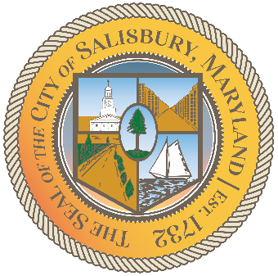

CITY OF SALISBURY

HUMAN RIGHTS ADVISORY COMMITTEE MEETING AGENDA

July 8th, 2021 | 6:00 p.m.
Government Office Building | Virtual Meeting

MEETING LINK— TBD

Opening meeting with a moment of silence

Item I Call to Order – Introductions and welcome 06:05 – 06:10
- Guests Invited
  - Cody Drinkwater

Item II Review May Meeting Minutes 06:10 – 06:15

Item III Current works for discussion 06:15 – 06:45
- Committee Logo, brochure
- July Grant application
- Final name for the Human Rights Award
- Award final draft
- Social Media Guidelines

Item IV Open public forum and current events 06:45 – until
- Open To All Campaign

Item V Announcements

Item VI Schedule next meeting and adjourn

