COVID-19 Essential Employee Authorization Letter

To whom it may concern:

On Monday March 30, 2018, the Governor of Maryland issued a “Stay at Home” Executive Order requiring the following:

All persons living in the State of Maryland are hereby ordered, effective as of 8:00 p.m. on March 30, 2020, to stay in their homes or places of residences (“Homes”) except:

- to conduct or participate in Essential Activities

Currently, there is not a state-issued "Letter of Clearance" or similar document for employees of essential businesses to carry. Therefore, in accordance to the Executive Order of the Governor of the State of Maryland, Number 20-03-30-01, please allow the below named individual to proceed to and from his location

- Employee Name: John W. Tull
- Employee Name: City of Salisbury Fire Department
- Address of Business: 325 Cypress Street
Salisbury, Maryland 21801
- Employee Title: Fire Chief
- Essential Activity: Emergency Services

We appreciate your support in allowing our colleagues to travel during the “Stay at Home” Executive Order as we continue to provide essential emergency service and public health assistance in the community.

If you have questions about this person’s affiliation with the City of Salisbury Fire Department, please contact the Fire Department’s Administrative Headquarters at 410-548-3120.
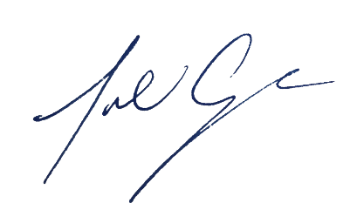
Yours in service,

Julia Glanz
City Administrator

