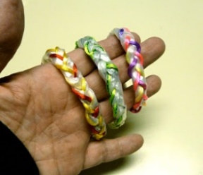
Recycled plastic bag braided bracelet
Materials: -Plastic bag loops -Satin cord in desired colors
-Clipboard -Clear Tape

Instructions:
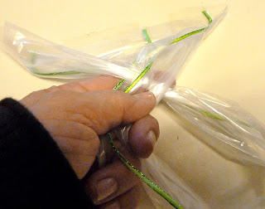
1. Choose loops of bag and cut one length of ribbon the same length as the bag pieces.

2. Clip one end of the 3 pieces under the clip of the clipboard.

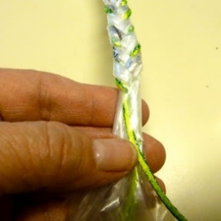
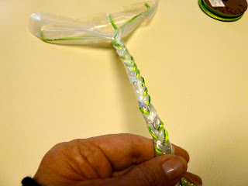
3. Begin to braid the sections using the middle one as the anchor. Over and under much like you would braid your hair. Continue down the bag keeping the same tension. When you reach the bottom wrap a piece of tape around the ends and cut to size if needed. Discard the extra cord and plastic.

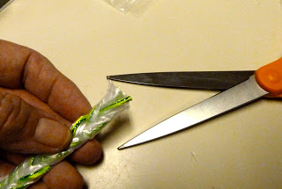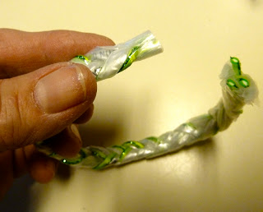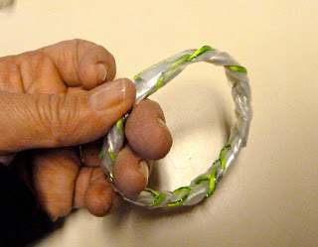

4. Bring both ends together, one on top of the other and carefully wrap clear plastic tape around to secure. Press tightly to make sure that the tape has secured the bracelet and add another piece of tape if needed.

