How to Make No-Sew Tote Bag Craft from Recycled Old T-Shirts

Crafts Materials Needed – Old T-Shirt – Scissors

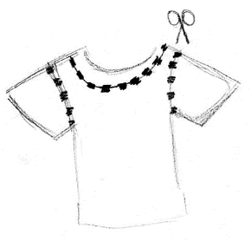
Step 1

Take out your t-shirt. Cut off the sleeves and a portion of the collar as well.

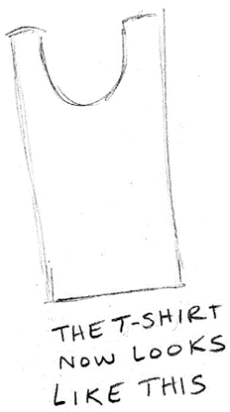
Step 2

This is what your t-shirt will look like after you cut off the sleeves and collar.

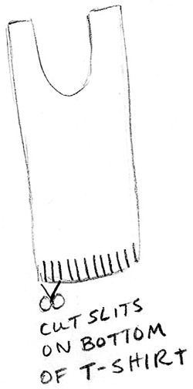
Step 3
Now cut slits on the bottom of the t-shirt (going through both sides). Cut each slit about a half inch apart. We are going to use these slits to tie the bottom of the t-shirt together with double knots. If you don’t know how to tie knots, then the instructions below will help.

\

Step 4 Step 5 Step 6
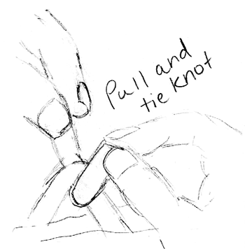
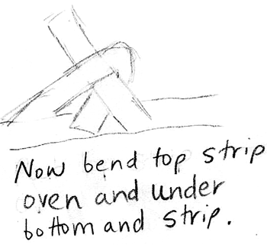
Now pull the 2 tabs sticking out until it is tight and you have one knot. Now do this process again to make a double knot.
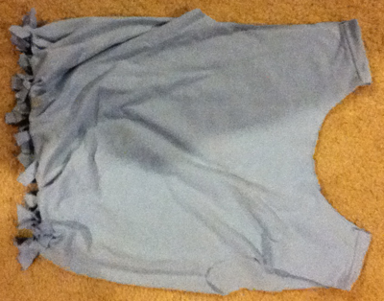
Step 7

After you have tied all of the slits together, your bag will look something like the above picture.

Step 8

This is what your bag looks like with stuff in it. It is very sturdy as this tote bag is filled with very heavy books. I hope that you had fun.

