Drawstring Sock Pouch
This Drawstring Sock Pouch project by Tiffany Threadgould is a great way to recycle those single socks whose partners were eaten by the washing machine. Follow the instructions:
Materials:
- sock
- shoelace or grosgrain ribbon for the drawstring
- straw
- scissors
- ruler

Instructions:
Cut two notches in the top hem of the sock. Make sure the notches are directly across from each other. Don't cut further than the hem. On most socks, the hem is about half an inch tall.
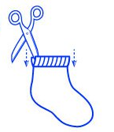
Next, cut the shoelace or ribbon to about a foot long. Cut the straw to 2 inches long.
Slip one piece of the shoelace or ribbon through the straw. Pull it back down against the outside of the straw.
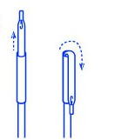
Slide the straw and the shoelace through one of the notched openings in the sock. Continue to thread the shoelace through the opening on the other side of the sock. Remove the straw from the shoelace. Your shoelace should create a loop around the inside of the hem of your sock.
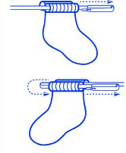
Tie the ends of the shoelace in a double knot.
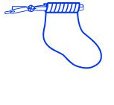
Repeat steps 4 and 5 for the second piece of your shoelace, but start on the opposite side of the hem.

