Cardboard Tube Binoculars
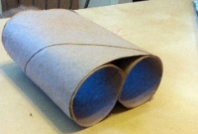
Materials: (per pair)
- 3 tubes - 1 length yarn
- 1 rubber band -crayons - scissors
- hole punch

Procedure: set 2 tubes side by side and wrap the rubber band around them.
Cut down 1 side of the 3rd tube and wrap overtop of the other 2 tubes (see picture).
Punch holes in each side and tie on yarn for hanging.
DECORATE!

