Can Tab Bracelet
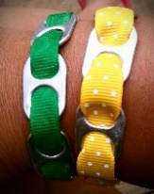
Materials: (per bracelet) - ribbon about 4-5 inches longer than student’s wrist
- can tabs
Procedure: measure out ribbon around student’s wrist leaving enough extra to account for can tabs taking up a little room, and enough to tie, allow student to string on can tabs, making sure to string ribbon through both holes of the tab. Tie bracelet around student’s wrist.

